Anexa 1
la Nota privind crearea rețelei de resurse educaționale deschise

Fisa de identificare RED

Nume/ prenume autor: Dan Adriana Loredana
Denumirea resursei educaționale propuse: PROJECT WORK
Tema/scurta descriere: Activitatea ”The Crown” presupune vizualizarea serialului, cercetare istorică, comunicare, cooperare între elevi, munca în echipă. Activitatea de tip proiect se adresează elevilor din clasa a X-a, nivel B2.
Scopul materialului propus:
- didactic (de utilizat la clasă/cu elevii)
- pentru elev (de utilizat de către elevi)
- de documentare pentru cadre didactice
- altele ………………………………….
Nivel de învățământ /clasa: a X-a
Aria curriculară/disciplina: LIMBA ENGLEZĂ
Material extracurricular: link-uri ale filmului serial ”The Crown” de pe Netflix, imagini, citate.
Competențe vizate:
- dezvoltarea competențelor de comunicare și scriere

The Crown

Level: 10th grade, intensively learning
Aims:
- to interact and communicate using specific language
- to cooperate within the groups
- to take innitiative
Skills: listening, writing, speaking
Language: reporting events; tenses: present simple, present continuous, present perfect, past simple, past continuous, future simple; vocabulary.
Organisation: project in groups
Time: 10 weeks project / 150 minutes classwork
Procedure:
A): The class is divided in 3 groups, each student will be watching season 1 of the Netflix series The Crown in 6 weeks, each group is given materials about this series.
B): Each student is given a list of the same questions regarding the series:
- What is the subject of the Netflix series The Crown?
- Who is the main character?
- Make a list of the characters and the relations between them.
- Establish the exposed period.
- Describe the historical and political context.
- Describe the exposed condition of the queen and of the royal family.
- What is your opinion regarding the living condition of the queen.
- What is your opinion regarding the living condition of the royal family members?
- What is your opinion regarding the relations between the royal family members?
- What is your opinion regarding the relations between the queen and the others members of the family?
- What is your opinion regarding the relations between the queen and the politicians?
- What is your opinion regarding the relation between the queen and the British people?
- How do the British people understand the involvement of the queen in United Kingdom`s evolution as a state?
- Expose your point of view regarding the way the world understands the British queen and the royal British family.

C): The answers will be given by all the group members and will be written on the worksheet.
D): Each group is asked to create a 15 minute new episode as a drama act.
E): Each group is given 2 weeks to write a new plot with the characters from the movie, each student of the group will be a character. The plot will respect the principles of the 10 episodes of the season 1 of the The Crown.
F): After this time expires, the teacher will read and adjust the 3 written dramas, will discuss with the 3 groups and will offer more instructions in order to manage the stage representation.
G): After 2 more weeks, on the established date, the 3 groups will present the dramas in the classroom, or in other more theatrical room (if the school has one).
H): The teacher will make notes regarding the props, the clothing, the gestures, the intonation, the actors’ dialogue, the plot, the involvement of each pupil/actor, the written project, the achievements of the group.
I): The others listen and have to compare, take notes and decide which drama is the most exciting one.
Teacher gives and explains the task, organizes the activity and the groups, coordinates, observes the groups activities, is present but does not interfere only if needed, answers possible questions, provides feedback.

Season 1

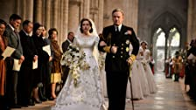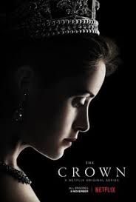
S1, Ep1

4 Nov. 2016
Wolferton Splash
A young Princess Elizabeth marries Prince Philip. As King George VI's health worsens, Winston Churchill becomes Prime Minister for the second time.

S1, Ep2

4 Nov. 2016
Hyde Park Corner
With King George too ill to travel, Elizabeth and Phillip embark on a four-continent Commonwealth tour. Party leaders attempt to undermine Churchill.

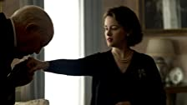
S1, Ep3

4 Nov. 2016
Windsor
With Elizabeth in a new role, Phillip tries to assert some power. Churchill wants to delay the coronation. King George's disgraced brother arrives.

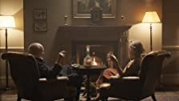
S1, Ep4

4 Nov. 2016
When dense fog cripples London for days and creates a serious health hazard, Churchill's inaction leaves him vulnerable to his political enemies.

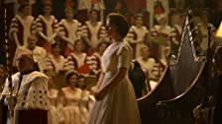
S1, Ep5

4 Nov. 2016
Smoke and Mirrors
Elizabeth rejects protocol by appointing Phillip to coordinate her coronation, but his ideas create conflict. The Duke of Windsor returns to London.

S1, Ep6

4 Nov. 2016
Gelignite
Margaret and Peter come to Elizabeth with a request. With a royal scandal about to break in the newspapers, the Queen Mother intervenes.

S1, Ep7

4 Nov. 2016
Scientia Potentia Est
As the Soviets test the H-bomb, both Churchill and Eden have major health crises. Angry about her inadequate education, Elizabeth hires a tutor.

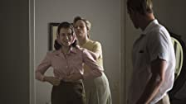
S1, Ep8

4 Nov. 2016
Pride & Joy
Elizabeth and Phillip go on an exhausting world journey. Margaret takes over some of her sister's official duties and tries to liven things up.

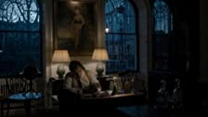
S1, Ep9

4 Nov. 2016
Assassins
As tensions with Phillip increase, Elizabeth spends time with her old friend Porchey. Churchill's portrait is painted for his 80th birthday.

S1, Ep10

4 Nov. 2016
Gloriana
Margaret and Peter are reunited, but another obstacle stands in their way. Elizabeth is torn between her duty as Queen and her love for her sister.
https://www.imdb.com/title/tt4786824/episodes?season=1

